18 PCS 10W RGBW leds par lights

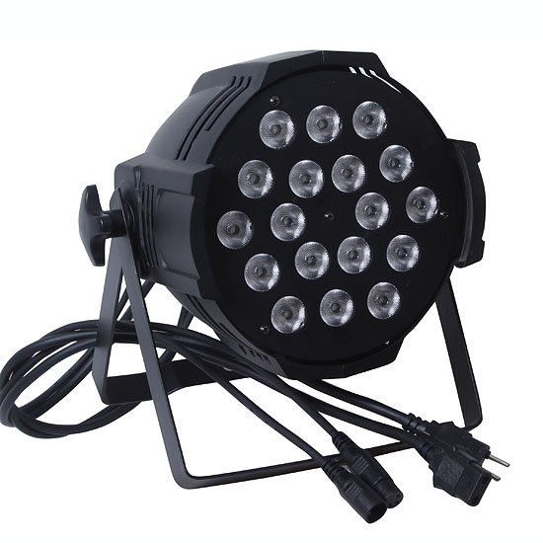

This manual contains important information.
Please read before operating fixture.

Thank you for using the company's production of PAR Light , users have to read and keep in accordance with the contents of the manual operation in order to ensure the right and safe installation, use and maintenance ; and the company assumes no responsibility when users are not in accordance with the requirements to install, use and maintain resulting in damaging to lighting, property or personal injury .
Please take good care of this prospectus when necessary.

1. SECURITY TIPS
In order to ensure your safety and the correct use of lighting. Please carefully read the following safety tips to avoid injury and unnecessary failures before use .
1, non-professionals, not the to disassemble the light arbitrarily and lighting accessories inside.
2, rated voltage range: AC110V-120V/60Hz or AC200V-240V / 50HZ (to be selected).
3, not beam irradiate the flammable materials, flammable materials and the lamp should be maintained at least 1M over the distance.
4, to keep away from the liquid substance and humid environment.
5, before using the lights must ensure the good grounding , can not install charging and remove any parts.
6, the installation of lamps, must be fixed screw fasteners with additional security cable and regular inspection.
7, lamps consecutive working hours is not recommended more than 10 hours.
8, should stop using the lights in time when happens unusual conditions during the process

2. TECHNOLOGY REFERENCE
1 Power supply: AC110-220V/50-60HZ
2 Power consumption:：200W
- Transformer：180W Input：110-220V/60HZ Output： 24V
- Lamp：18pcs 10w RGBW leds
- package size：60×60×43cm (4 PCS IN ONE CARTON)
- G.W.：36 Kg
- Grounding resistance：≤0.5Ω

3. FUNCTIONS INTRODUCTION
1、International universal control signal: DMX512
2、8 DMX channels
3、Digital display
4、Strobe、sound control、auto.
5、Programmed inside
6、Adjustable flash frequency

4. DISPLAY CODE SETTING METHOS
Each computer lamp should be endowed with a digital starting address number to guarantee the computer lamp may response to the correct control signal. The digital starting address number is a channel number by which the computer lamp only can follow the numerical control instruction from the controller. This computer lamp has used 12 numerical control channels, the digital starting address is set by stirring the LCD on board which comes to regards as the digital start address value.

Computer lamp numeral starting address computation method:
Current computer lamp numeral starting address = (Last computer lamp numeral starting address value) + (controller basic channel number).

Illustration:
(1): The first computer lamp numeral start address value is 1
(2): The controller basic channel numbers should be bigger than or be equal to the computer lamp used numerical control channels.

5.OPERATING ILLUSTRATION

1) Digital display function of the final point of the current mode of operation used to indicate whether the change, if the current mode of change, however, the light, press confirm button to save after that point out.
2) If an explicit content of both figures show that the contents of the letter there, when between the letters and numbers separated by points.

Content of display | Function | Notes
 | DMX control mode | "D" means DMX mode, the latter three numbers (001-512) that the current DMX address of the value of the lamp
 | Gradual change Color operation mode display | "CF." means the color gradual change, followed by two numbers (00-99) that the speed of color change
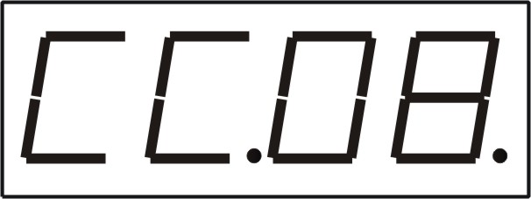 | Instantaneous color change operation mode display | "CC." means the color transient, followed by two numbers (00-99) that the speed of color change
 | Choose a fixed color mode display | "CS." Expressed preference for a fixed color, followed by two numbers (00-99) that a color
 | Music activated | --
R001 | Red adjustment | 1--255
G001 | Green adjustment | 1--255
B001 | Blue adjustment | 1--255

Keys function instruction
Name of keys | Function
FUN | Function Switch
UP | Parameters plus Enter key
DOWN | Parameters reduce Enter key
ENTER | To confirm the save button
Function Switch operation ：
- By the key FUN to select the various functions.
- By the keys UP and DOWN enter (or modify) the current function of item parameter values；
- Press the ENTER key to save the currently selected function item, (only saved, the next turn to enter the current settings of the operating mode).

Each function operation instruction
The par consists of the following three kinds of operating modes, where (music-activated operation, auto run feature, gradual change color features, color features and options instantaneous transformation fixed-color output function) belong to the master mode1）DMX mode.
2) Master mode (including: music-activated operation, auto-run function, gradual change color features, color features and options instantaneous transformation fixed-color output function).
3）slave mode.

一）DMX mode ：
In this mode, the par receives the format internationally DMX512 lighting console, the control signals.
1）Enter the DMX mode:
★By the FUN choose“d.001”；
★By the keys UP and DOWN Set the DMX address of the value of the current lighting；
★Press ENTER to save the currently selected function ite

7 . DMX CHANNEL SHEET
DMX | DMX VALUE | Detail functions
CH1 Total dimming | 0~255 | Total adjustment
CH2、Strobe | 0~255 | Strobe switch and speed adjustment
CH3、Auto | 0~10  11~252 | Dimming function, color gradual change and color transient function of switching functions
CH4、Speed | 0~255 | The color gradual change and color transient speed regulation
CH5 Red | 0~255 | R from dark to all bright
CH6 Green | 0~255 | G from dark to all bright
CH7 Blue | 0~255 | B from dark to all bright
CH8 White | 0~255 | W from dark to all bright

Note:
Based on our company continue to improve the product, the statement containing data may have changed, and will not notice the change any more. Company retains its right to change specifications related when product is improved. Thanks for your understanding

